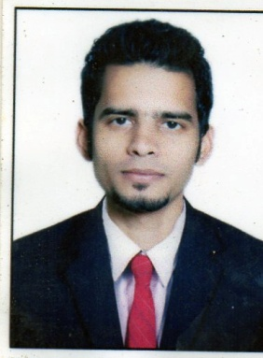
Musaddique M. Pawaskar

Contact: +91 7045663496/+91 8976637251 E-Mail: musaddique_extc@yahoo.com

CAREER OBJECTIVE
PROJECT
Robotics-Line Follower
ELECTRONICS TECHNOLOGY-Vocational course
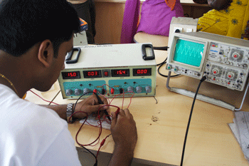

DIPLOMA
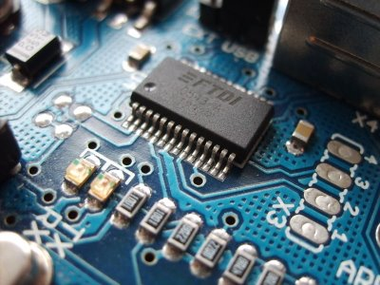
ELECTRONICS & TELECOMMUNICATION
ENGINEERING

- To obtain a full time position that will enable me to use my strong organizational skills, educational background and ability to work well with people.

EDUCATION

EXAM | NAME OF INSTITUTE |  | YEAR OF PASSING |  | % MARKS |  | MAIN SUBJECT
SSC | S.N.M. high school Kharepatan, Kankavli, Dist:Sindhudurg-416703 |  |  | Mar-2007 |  | 69.40 |  | Maths, Science
HSC | P.L.Patil Junior College Kharepatan |  |  | June-2009 |  | 69.00 |  | Basic Electronics, Basic Electricity Material

DIPLOMA IN ELECTRONICS & TELECOMMUNICATION ENGINEERING)
CLASS |  | YEAR | % MARKS |  |  |  | GRADE
CLASS |  | YEAR | 1st Semester | 2nd Semester | Average |  | GRADE
1st Year (EXTC) |  | 2009-10 | Exemption | Exemption | EX |  | EX
2nd Year (EXTC) |  | 2009-10 | 57.38 | 60.00 | 58.69 |  | SECOND  CLASS
3rd Year (EXTC) |  | 2010-11 | 69.18 | 69.39 | 69.45 |  | FIRST  CLASS

WORK EXPERIENCE

COMPANY PROFILE

- Argos International (Kalpatru Group) Global manufacturing, and trading company dealing in Polymer, Medicine, Petrochemical, Lighting Solutions etc.
- Argos international provide with the highest quality LED indoor lights, Outdoor lights and industrial light etc.

ARGOS Internation Pvt Ltd. As an R&D Executive From 4 May 2015 To till date.

- As a part of R&D, I have to keenly and correctly testing the products which follow all necessary standards & regulation. Technically solve the issues & deliver the best product.
- Design & Development in the circuit.
- Testing & Measurement of all Parameters and validation of LED products.
- Knowledge of handling of Electronic Instrument for testing purpose & Debugging required in Power Electronics & Lighting sector, such as Oscilloscope, Power Analyzer, Lux meter,Thermal Imager, LCR, DMM etc.
- Documentation.
- Components selection, BOM preparation.
- Searching New Technologies Developed.
- Monitoring & Tracking the products during production line.
- Maintaining the fault if found during production.

Completed project
- Developed up to 200W LED Street Light with Standard Specification.
- Developed LED Drivers up to 70W in Single Stage.
- Work start on developing 90W to 140W in Dual Stage.
- Develop & Design almost complete range of Street light, down-lighter, square panel, flood light, COB light etc. Also completed PWM & Analog dimming lights.
- Developed LED Bulb, Tube lights, & consumer lights.
- Tested solar products, (Solar Street Light, PWM Charge Controllers, and Solar Invertor).
- Developed Aesthetic Light (Wall-Washers, RBGW Focus-light, Wall Lamps, and Architectural Designer Lights etc.)

M.R.Electronics Pvt Ltd. As an testing engineer from March 2014 to April 2015.

Over all 14 Months experience as an Testing Engineer – Sairush Electronics System, from November 2012 to December 2013

IT SKILLS

- Simulation Software: keil , 8085 simulator, TI-debugger/programmer
- Operating systems (Window 9X, Window 2000 & Window XP)
- MS Office 2003 & 2007 (Excel, Word & PowerPoint)

Passport detail

Passport No.: K7543123
Place of issue: Mumbai
Date of issue: 22 November 2012
Date of expiry: 21 November 2022

PERSONAL DETAILS
Date of Birth : April 03, 1991
Nationality : Indian
Linguistics : English, Hindi and Marathi
Gender : Male
MaritalStatus : Single
Weight : 50 kg
Height : 5.4ft
HOBBIES AND INTERESTS : Playing cricket &Watching movies
Permanent Address : At Post- Katali, Taluka- Rajapur,Dist- Ratnagiri (Maharashtra)

Current Location : MUMBAI-WaDALA ANTOP HILL

Current SALERY-ctC : 2.5L (ANNUAL)

Expected salary : Negotiable

